October 15, 2020
CITIBANK TRAVEL CARD APPLICATION/INSTRUCTIONS

Employees who apply for a Citibank government travel card must complete the Statement of Understanding (SOU) and the GSA Travel card training certificate PRIOR to completing Citibank’s on-line Travel Card Application. Employees who apply on-line and fail to submit the SOU and GSA Travel Card Training Certificate run the risk of having their application rejected. Please submit the following two documents PRIOR to submitting the on-line application and ensure that all three are completed in the same day and at the same time.
- Statement of Understanding (SOU). Once you complete the SOU, you must sign and date it and forward it to your supervisor who will also sign and date it. Once completed, you will need to forward the SOU to Chasity.N.Grimm@noaa.gov and cc Rachael.S.Wivell@noaa.gov.
- GSA Travel Card Training. You are required to take GSA’s travel card training. Once you have read the material and completed the course, you will receive a travel card training certificate. You ARE REQUIRED to download the certificate into a pdf format and forward the travel card training certificate to
Chasity.N.Grimm@noaa.gov and cc Rachael.S.Wivell@noaa.gov. If you are retrieving an old training certificate, it must be valid within 3 years. Otherwise, you will be required to retake the course.
- See the next page to apply for the Citibank travel card……
IMPORTANT UPDATE:
When you enter your E-Mail Address in Citibank’s on-line application YOU ARE REQUIRED to include your NOAA E-Mail address to ensure you receive the One Time Passcode (OTP) required to log into your CitiManger account. Citibank WILL NOT send an OTP to any other E-Mail address. Your E-Mail address must end in @NOAA.GOV or you will not be able to log into your on-line Citibank account.

If you do not include your NOAA E-Mail address, we will either reject your application or change it to your NOAA E-Mail address. If you do not have a NOAA E-Mail address because you are new, please apply when you receive your NOAA E-Mail address.

1

STEP 1: Invitation Passcode/Inviter’s Email.
- Open this link: Citibank Travel Card Application to launch the User Registration section of the application.
- Select the Invitation Passcode option.
- Click Continue.
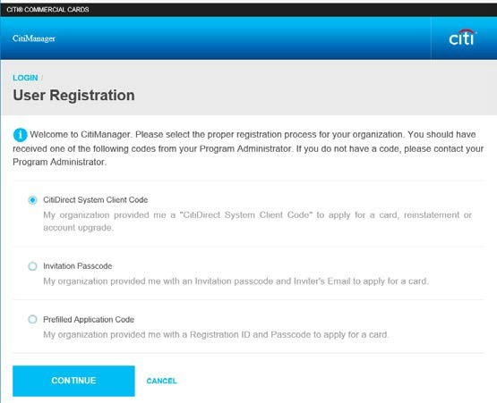

This will open the User Registration –Invitation Passcode/Inviter’s Email screen.
- Enter NOAA2901544T in the Invitation Passcode field.
- Enter Rachael.S.Wivell@noaa.gov in the Inviter’s Email Address field.
- Click Continue.
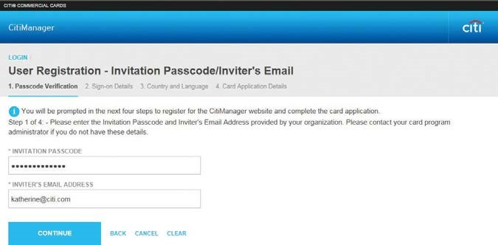

2

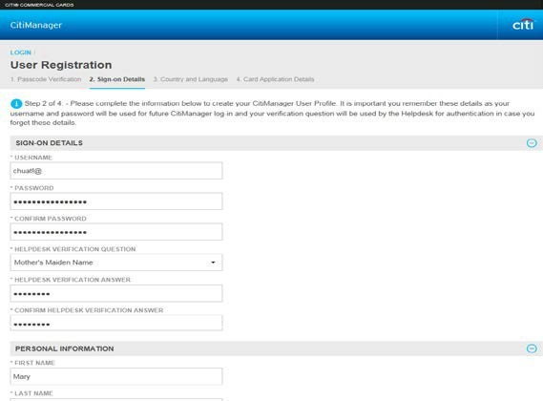
Step 2: User Registration.
- Complete the required fields in the Sign-on Details and Personal Information Sections. It is important you remember these details as your User Name and Password will be used for future CitiManager log-in and your verification question will be used by the Helpdesk for authentication in case you forget these details.
- Click the continue button and a confirmation message will display.

Note: The password and username requirements display in a window as you type your password. A checkmark displays when the requirements are fulfilled. The CitiManager site will send you an email confirming the registration and username created.

Error Messages: If you receive the error message below, it means that someone else already has the User Name you selected. Therefore, you will need to select a new User Name. Citibank services multiple Federal agencies and private companies which may make it difficult to come up with a unique User Name. If you experience any issues that prevent you from getting past this step, please contact Citibank directly at 866-319-7251
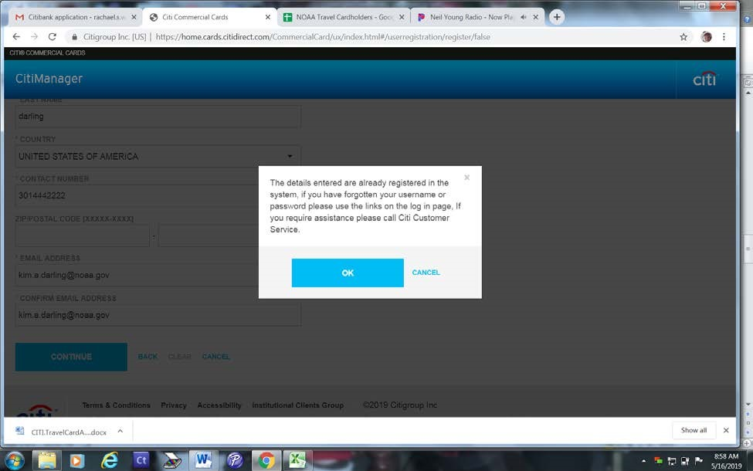

3

Step 3. Country and Language.
- This step was automatically completed for you.

Step 4 Application Details. Complete only the areas with an asterisk (*).
NOTE: Citibank only accepts residential home addresses and will reject any application that shows a P.O. Box for card delivery.

- Under E-Mail Address, include your NOAA E-Mail address to ensure you receive the One Time Passcode (OTP) required to log into your CitiManger account. Citibank WILL NOT send an OTP to any other E-Mail address. Your E-Mail address must end in @NOAA.GOV or you will not be able to log into your on-line Citibank account.
- Under Approving Group Name, select NOAA (2901544)
- Under Supervisor’s E-mail Address, select Tiffany.Y.Gaymon@noaa.gov.
- Select if you want the card mailed regular mail (7-10 business days) or expedite (3 business days and someone must be home to sign for the card).
- For ‘Verification Information Answer’ – ignore the request to enter your employee ID. DOC requires you to use the last 4 digits of your SSN as the answer to the Verification Information.
- Upon completion, hit Submit at the bottom of the form and then hit OK. You will receive The CitiManager Login Screen. Your application has been successfully routed to your supervisor for approval. Once your supervisor approves it, your application will be forwarded to your servicing APC for final approval before being submitted to Citibank.

4

