How to Format Reports in PaymentNet

1. Go to:
https://gov1.paymentnet.com
2. PaymentNet Login Screen:
Organization ID = USDOCSP (show all CAPS)
User ID = First initial of first name and first 4 letters of your last name
(i.e., John Smith- JSmit)
Pass Phrase = password (all lower case)

Under the Pass Phrase field, check the box in front of “Remember my ID”. This will save your Organization ID and User ID. (You will not have to re-enter this information when you access PaymentNet again.) It will not save your Pass Phrase.
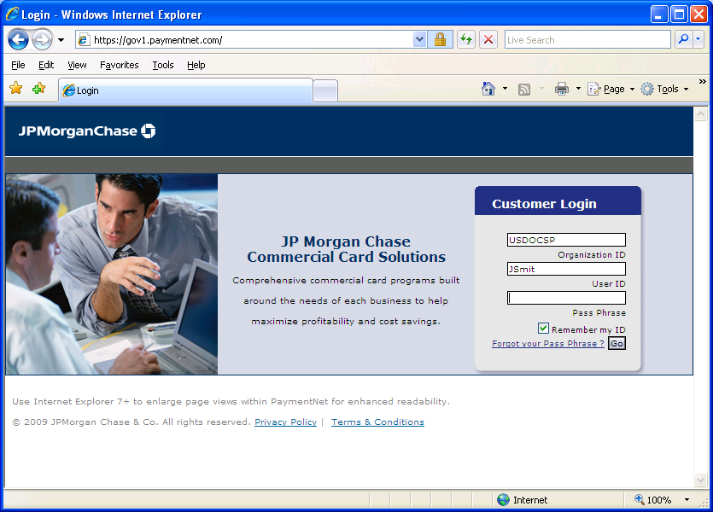
Navigating in PaymentNet
The top Menu Bar lists the modules your PaymentNet login ID can access (Transactions, Reports, Accounts, Payments, Administration and Help).
The Help feature can provide you with “Help for Page” and use of the“Help Index”. The Help feature is a useful tool for you to use in PaymentNet.

On the Menu Bar are four Icons:
Home – Returns the user to the Welcome Screen
Contact Information – Lists important contact information for your program
My profile – Takes you directly to your PaymentNet profile
Logout – Allows you to securely end your PaymentNet session
Please note: Your PaymentNet session will automatically “time out” after 15 minutes of inactivity

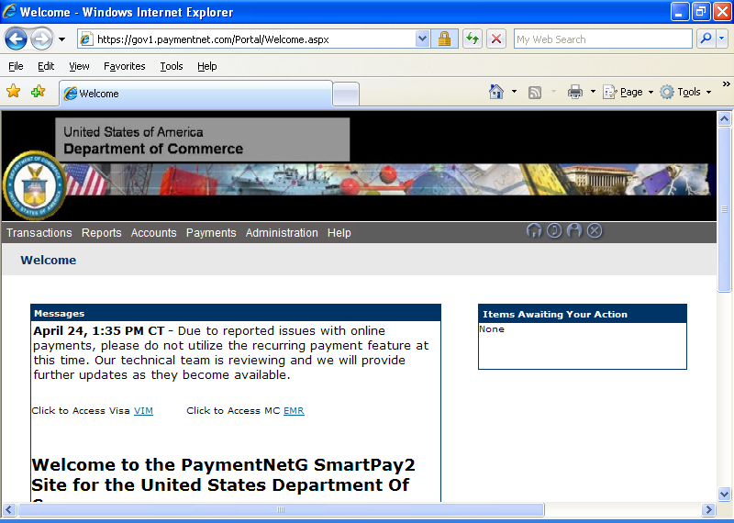
Enable E-mail Notifications for Reports
You can receive e-mail notifications from JP Morgan Chase to let you know when a report that you ran in PaymentNet is ready for you to review. When you enable e-mail notifications and have already set-up your reports to run automatically, you will receive an e-mail notification that your report is ready to view.

Log into PaymentNet
On the gray bar across the top of the screen (menu bar), you will see an Icon that is a figure of a man. This is where your profile in PaymentNet is located.
Click on the “My Profile” Icon
Under “Available Downloads”, check Reports and then click on Save (top left hand corner of page). You now have enabled e-mail notifications for your reports.

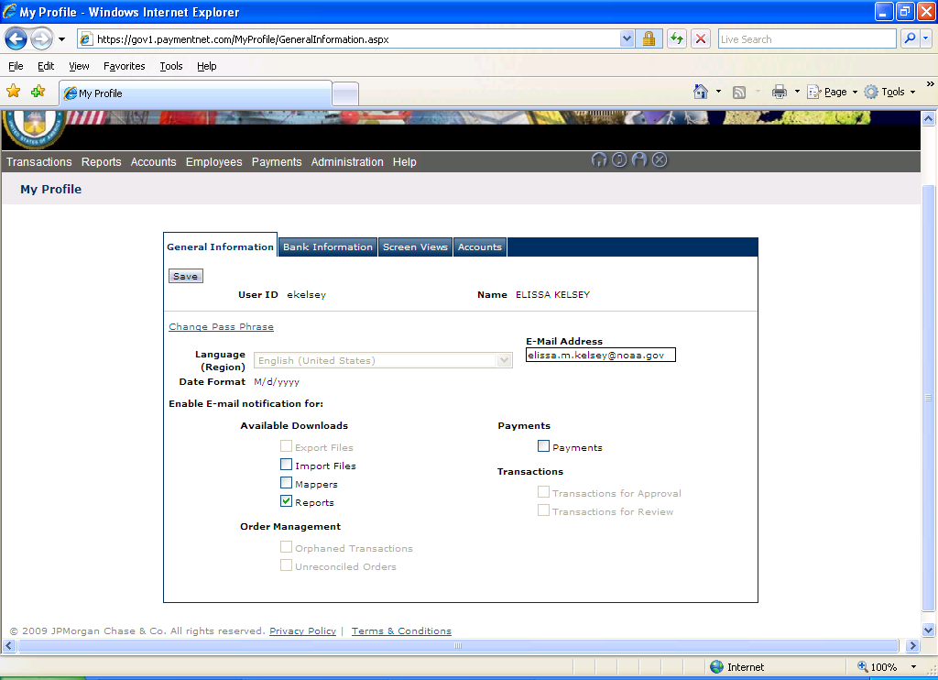

Viewing Individual Travel Card Accounts
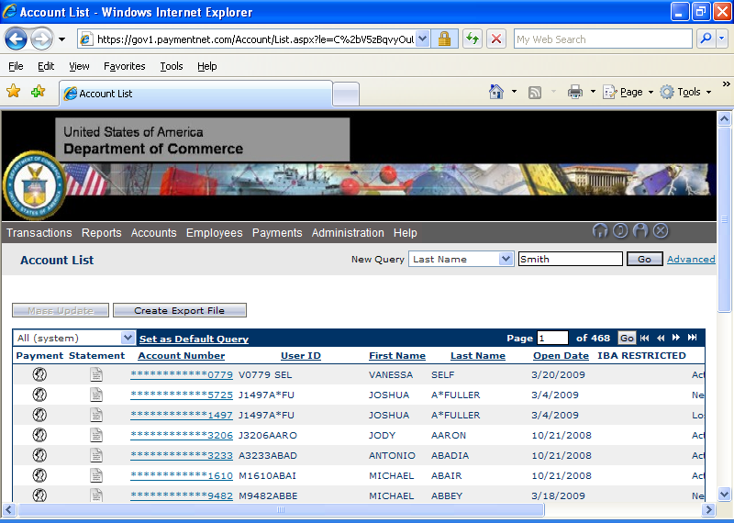
To view the account, click on the Account Number
You will be able to view an individual cardholders’ name, address, status, hierarchy, credit limit, current balance and available credit. For PII security, this screen will not be displayed.
Click on List (top right hand corner), to exit the account and return to the previous screen
When you have returned to the original screen:
To view a cardholders’ statement, click on Statement Detail, which is to the left of an Account Number. Click on Return to Account List (top right hand corner), to exit the statement detail and return to the previous screen

Monthly JP Morgan Chase Reports
Each month you will review the listed JP Morgan Chase Reports to monitor your travel card accounts under your Hierarchy and to check for Misuse and Delinquency. Reports are best viewed in Excel, but can be viewed in PDF as well. Some reports will indicate the format to use. A report without data indicates that there is no activity to review for that month.
Run the following reports on the 5th of each month:
Cardholder Listing by Hierarchy – This report will show the travel card accounts that are listed under your hierarchy. This report is used to make sure the correct travel card accounts are listed under your hierarchy and it will also show you the status of the travel card account. This report can also be used to verify account closures.
Accounts Renewing Within Three Months – This report identifies accounts that will expire within three months of the report date. This report is used to check for accounts that should be canceled.
Delinquencies with Current Balance – This report will show delinquent accounts that are 30 days past due, 60 days past due, 90 days past due, etc. The travel card monitor will notify the employee and the employee’s supervisor of a delinquency when the cardholder’s account is 31-60 days past due. The A/OPC will issue a delinquency memo to the cardholder when an account is 61 or more days past due.
Declines – This report will show charges that have been declined and will indicate the reason for the decline. This report is useful to monitor potential travel card misuse and can also be an indicator of possible fraud on an account that may be unknown to the cardholder.
Cash Advance Detail by Hierarchy – This report shows cash advance charges from the cardholders. This report is used to monitor potential misuse of the travel card by a cardholder who may be making cash withdrawals while not on official government travel.
Unusual Activity Analysis – This report will show unusual transaction activity. (No data may be found when you run this report, because there is not any unusual transaction activity to report for that month) This report is used to determine if a transaction was misuse of the travel card.
Transaction Detail – This report will show you all purchase transactions incurred within the month and should be used to monitor misuse.

Running Monthly Reports
The following information will show you how to run a JP Morgan Chase report. I am using the report “Cardholder Listing by Hierarchy” as my sample.

Click on Reports and then click on Create

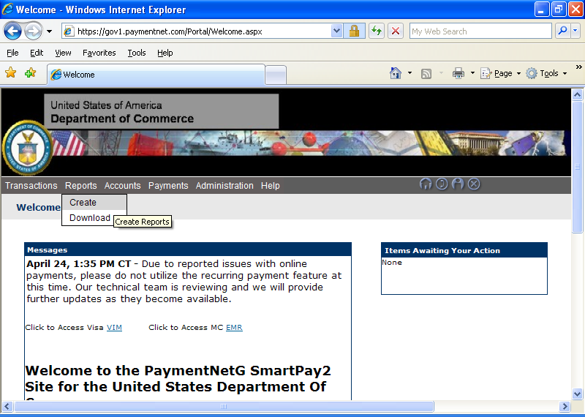

Click on “Cardholder Listing by Hierarchy” to select the report

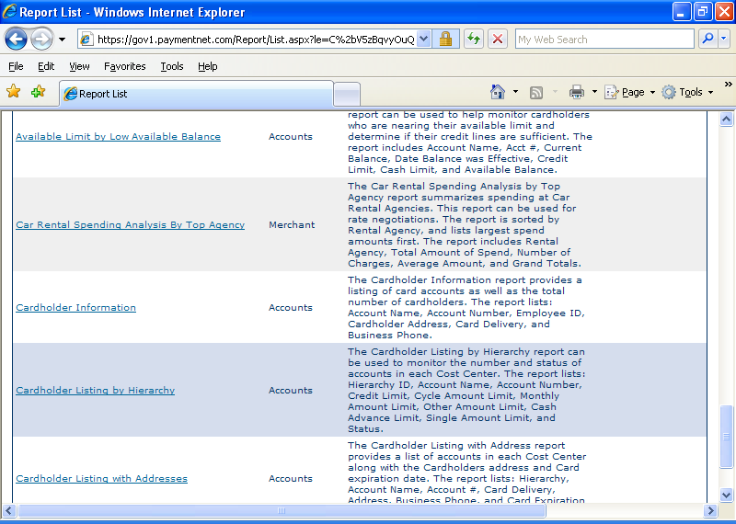

At the Report Format field, click on the drop down arrow and select the report format that you would like to use
Click on Process Report at the top of your screen to run your report
(You are already set-up at your correct hierarchy. Your reports will have the travel card accounts that belong to your hierarchy)

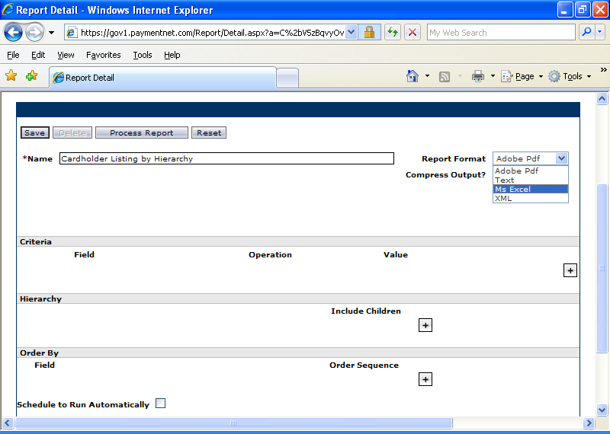

Your report may take several minutes to finish running. If you do not want to wait for the report to finish, you may go to other tasks. If you enabled email notification, you will be notified by e-mail that your report is ready to view.
Click on Cardholder Listing by Hierarchy to view your report

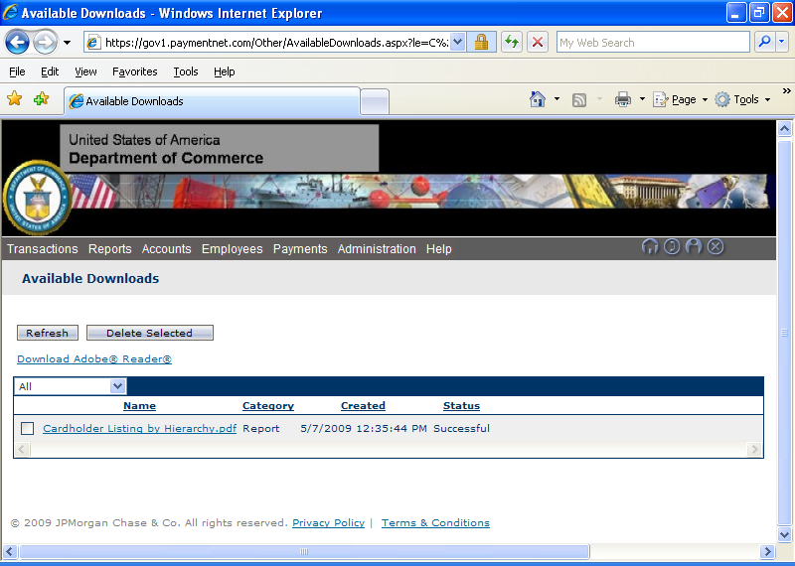

To Delete a report, click on the box to the left of the report name and then click on Delete Selected
To Save a report, click on File and Save As. Select how you would like to save your report
Please Note: The Reports module does not allow you to go back to a previous screen using the back arrow. You will need to click on Reports and select Create to return back to the reports section

To run a Transaction Detail report:
Click on “Report” Tab, and then “Create”
In the upper left corner where it says “All”, click on the dropdown menu and select “Transaction”
Go to the second page of reports and select “Transaction Detail”
Under “Name”, rename the report
Under “Report Format” select, Ms Excel
Under “Criteria”:
- click on the + sign
- under “Field” it will show “Accounts”, click on dropdown menu and select Post Date
- under “Operation”, click on the dropdown menu and select “Is Relative”
- under “Value”, select, “Last Period” and then “DOC 3rd”
Under Hierarchy, click on the + sign and select your hierarchy level
Under “Order By”:
- select “Schedule to Run”
- under “Frequency”, select “Cycle”
- under “Cycle”, click on “DOC 3rd”
Click on “Save” in the top left corner
Click on “Process Report”

To schedule a report to run automatically each month:
Click on Reports and then click on Create
Select the Report that you would like to receive each month
When you are at the Report Detail screen, check the box at Schedule to Run Automatically
At the Frequency field, click on the drop down arrow and select Monthly
At the Day field, click on the drop down arrow and select 5 (to receive the report on the 5th of the month)
Click on Save
Your report is now saved. You will receive an e-mail from JPMC each month to notify you that your report is ready to review
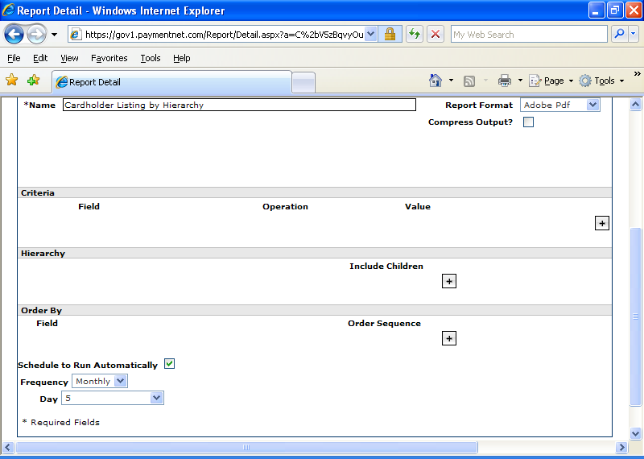
You can view reports without saving the report by clicking on the report name under “Available Downloads”
To View your reports that you have saved, go to the Reports List screen
Click on the drop down arrow at the top of the screen
Select My Reports
You will now see the reports that you have saved

