The purpose of this report is to assist LO/SO budget analysts with linking the fee for service surcharge transaction amounts back to their source transactions. This quick reference guide will walk you through the steps on how to access and utilize the report.
NOTE: A Temp folder on your C drive must be created (If one doesn’t already exist) before running this report. This report is only generated in .CSV format.

- Launch QR101 – Quick Reports from the CBS Navigator Menu  - Click Ok on the WebUtil Information screen | 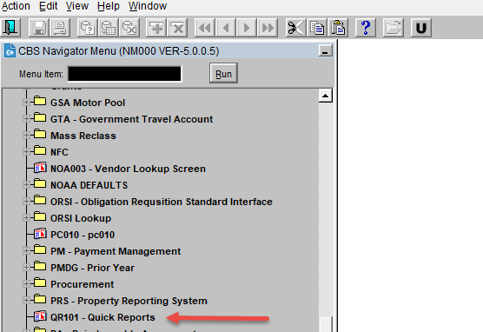  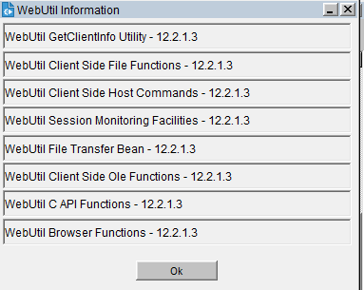
- Click in the Report Header Field which launches the REPORT HEADER screen  - Enter FFS next to the percent sign and click on Find.  - FFS-Surcharge Report-CSV FILE ONLY will be displayed and highlighted  - Click on OK | 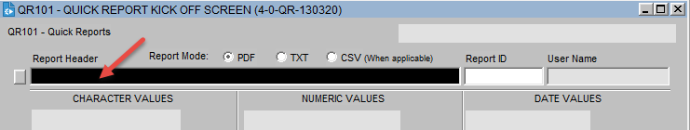  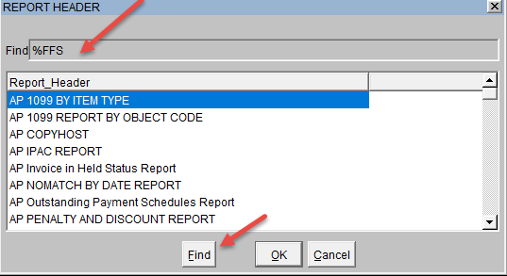  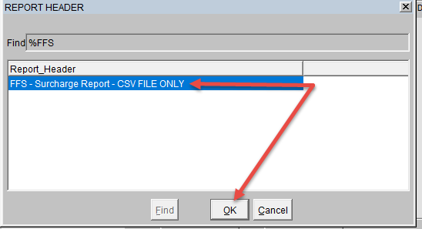
- System will display the FFS-Surcharge Report query screen (Report ID: QR0097) | 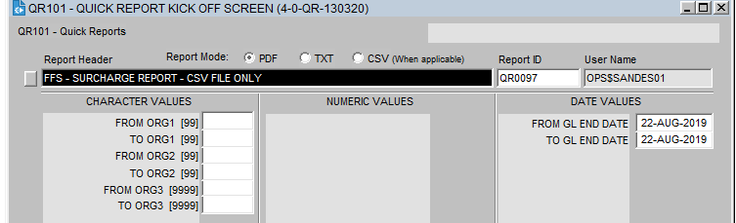
- Click on CSV option next to the Report Mode  - Enter the ORG code Query Values NOTE: If you are querying only on first org code level remember to leave rest of the org code fields blank  - Enter GL END DATE range and Click Submit  NOTE: Users can only query up to 3 months. | 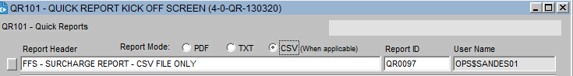  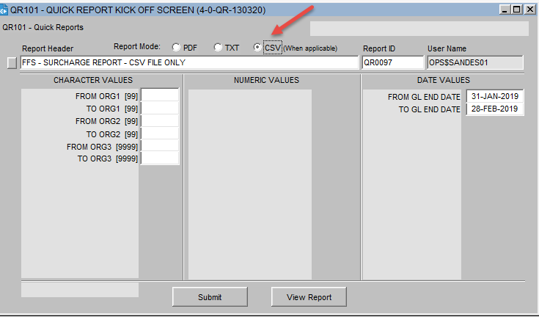
- System will display PLEASE WAIT on the bottom left of the screen while the report is running  Click OK on QR101:Submit pop up message  Click OK on the Forms pop message  Click OK again on the second Forms message  NOTE: This message indicates the path of the folder where the report will be saved. This report will always be saved on your C Drive under the Temp folder | 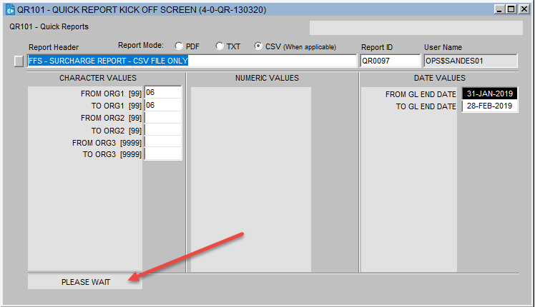  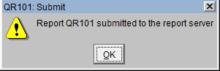  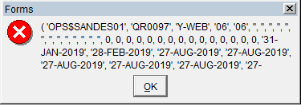  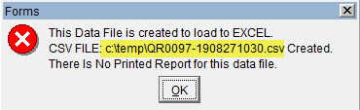
- Report will be saved in your Temp folder in your C drive.  Double Click to Open file  File open in Excel.csv format. | 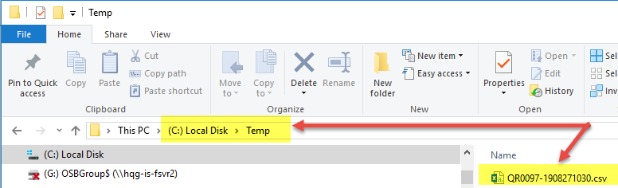  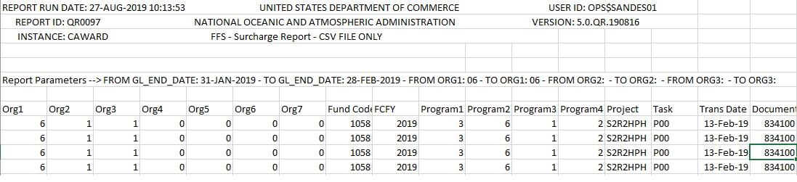

Frequently Asked Questions

- Q. Why am I getting a blank report with the following message in it?
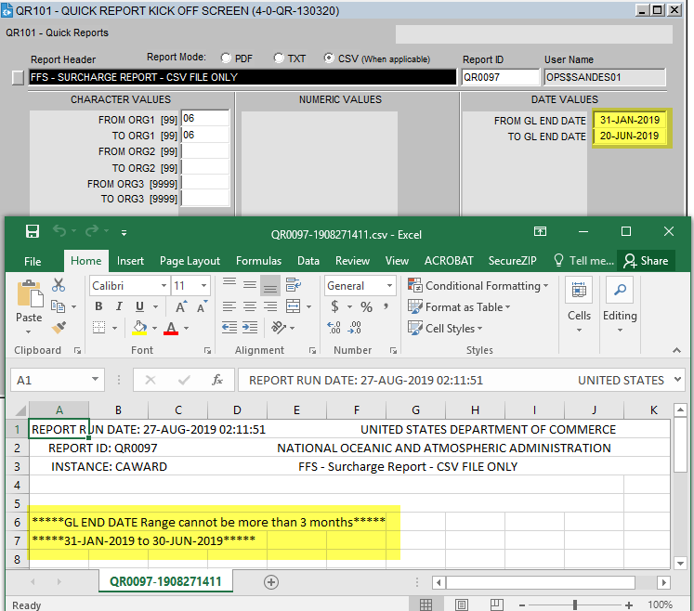

- This is expected behavior when a user enters a GL End Date range beyond three months. User can only search up to 3 months.

- Q. Why am I seeing the following message when I open up the downloaded report?
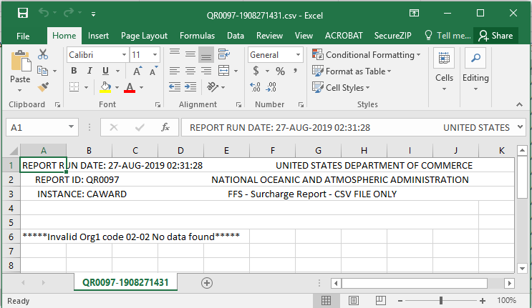

- Users will encounter this message on their .CSV report output if they search under an org code that does not exist in the system.

- Q. Can I search only on Org Code 1?
- Yes. But remember to keep org code 2 and 3 fields blank.

- Q. What happens if I forget to check the .CSV Report mode before running the report?
- System will either generate a blank .PDF or .TXT report depending on the Report Mode selected

- Q. Why am I not seeing my surcharge on this report?
- The surcharge will only show once Finance Reporting Division [FRD] has ran the surcharge process.

