The purpose of this document is to provide Program Officer’s (PO) with a step-by-step process for conducting renegotiations in Grants Online. The PO uses renegotiations when a document is locked and revisions are needed.

Step 1: Log into Grants Online and select the “Tasks” hyperlink from the menu bar on the left. The PO should view the “Certify/Revise Award File”. Please note: If there is no task to “Certify/Revise Award File”, the PO must confirm at least one of two things:
  - Has the PO Checklist been completed yet? If not, complete the PO Checklist and the task will appear in the inbox.
  - Has the award file been sent back to the PO for revision. If the Award File has been forwarded, it must be returned before the PO can renegotiate.

Step 2: Select the “View" hyperlink from the “Certify/Revise Award File” task that you would like to modify.

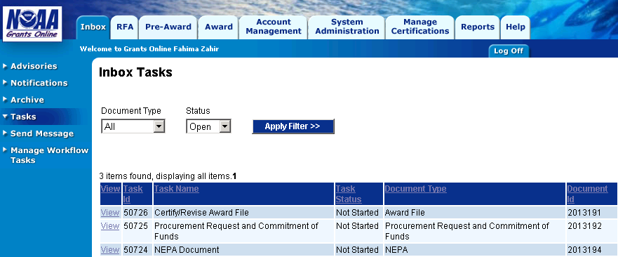
“View” Hyper-links
“Tasks” Hyperlink

Step 3: Select “Renegotiate” from the action drop down menu and click the “Submit” button. This will take you back to your task inbox screen.
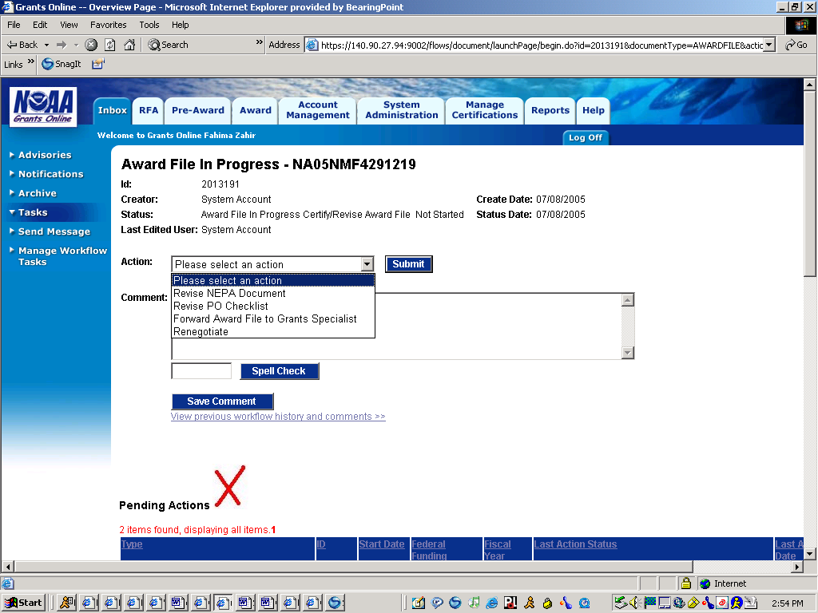
“Renegotiate” Action

Step 4: Refresh your inbox by clicking on the tasks hyperlink found on the left menu bar. Select the “View" hyperlink from the “Conduct Negotiations” task.

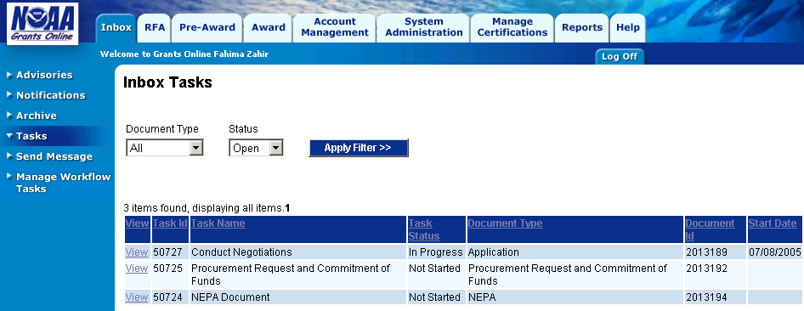
“Conduct Negotiations” task

Step 5: From the action drop down menu, select the document that you would like to modify such as the application, NEPA document, Procurement Request or the PO Checklist. For this example, “Revise PO Checklist” has been selected. Be sure to click the “Submit” button.
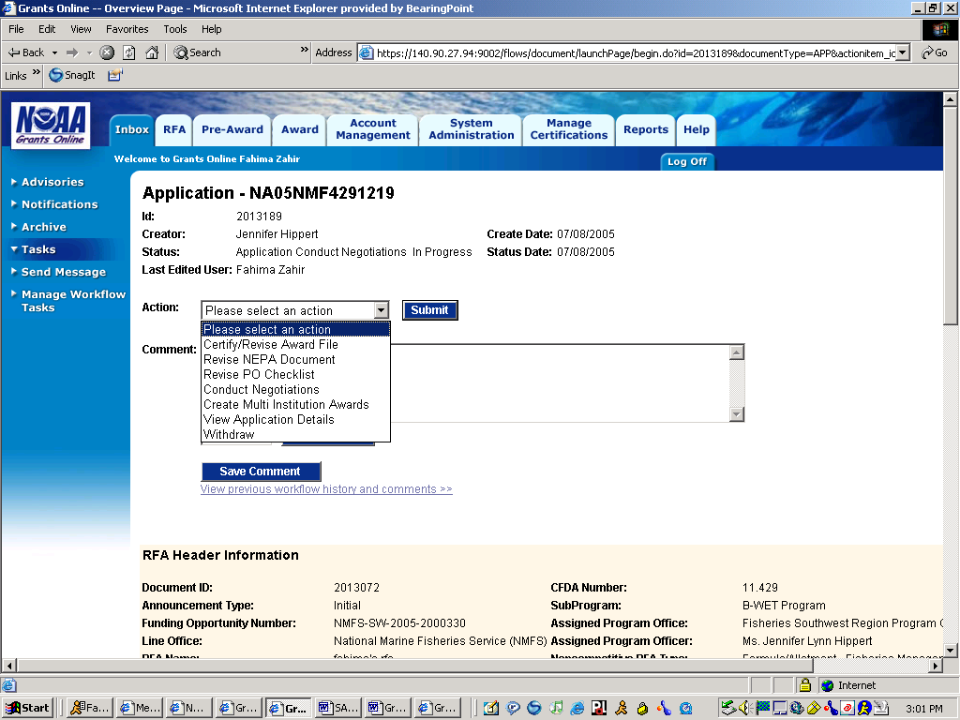
“Revise PO Checklist” Action
Step 6: The next screen will take you directly to the document itself. For example, since “Revise PO Checklist” was selected, the next screen is the PO Checklist screen where modifications to the PO Checklist can be made.

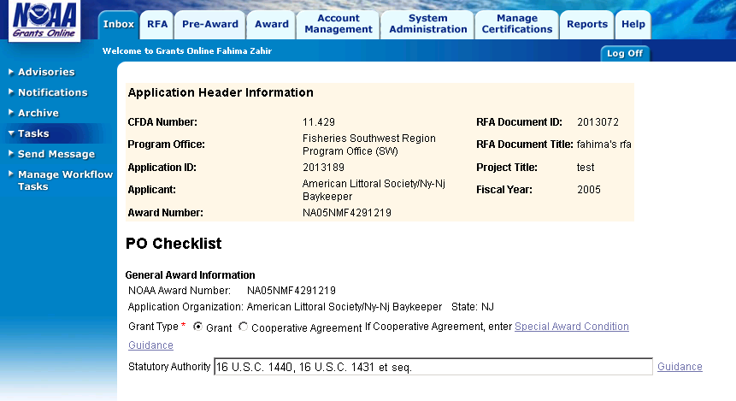

Step 7: After modifying the document, select the “Save and Return to Main” button located at the bottom of the screen.

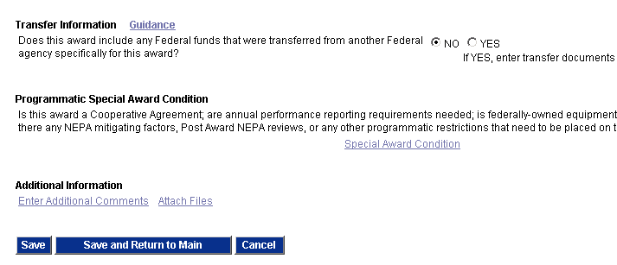

Step 8: Select the “Certify PO Checklist” action from the drop down menu and click the “Submit” button.

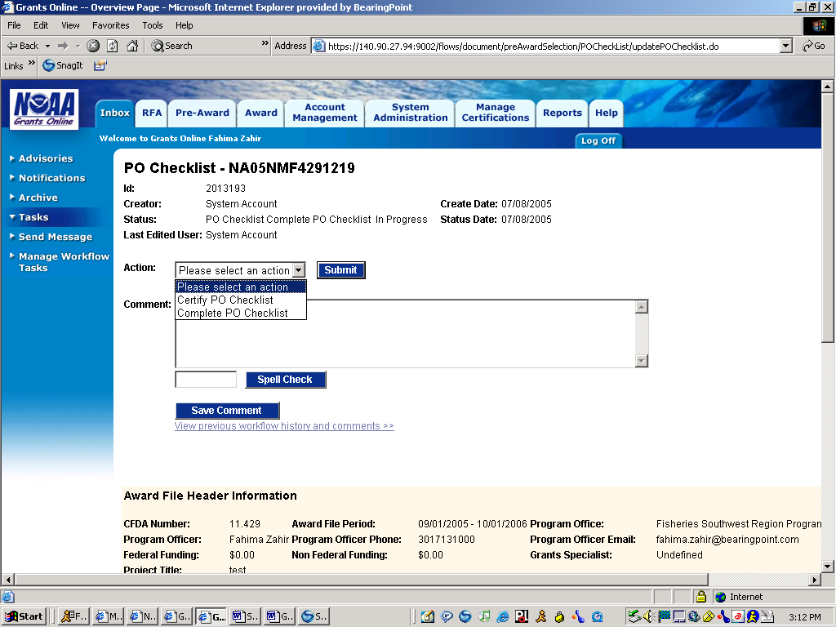
“Certify PO Checklist” Action

Step 9: The next screen is the task inbox screen. Remember to refresh your tasks. Select the “View" hyperlink from the “Conduct Negotiations” task.

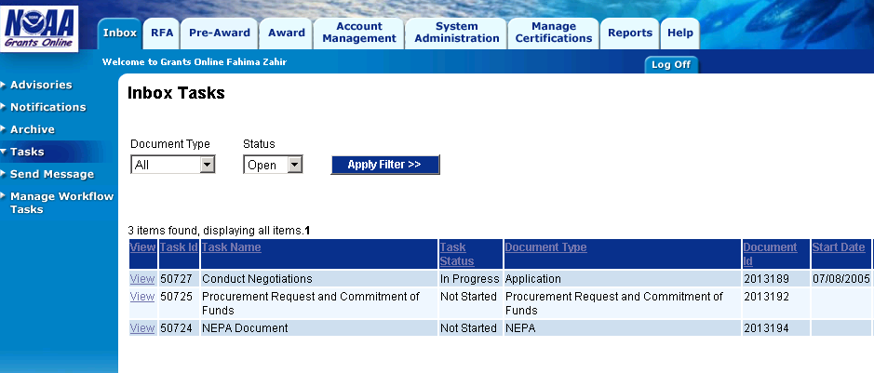
“Conduct Negotiations” Task
Step 10: Select the “Certify/Revise Award File” from the action drop down menu and click on the “Submit” button.

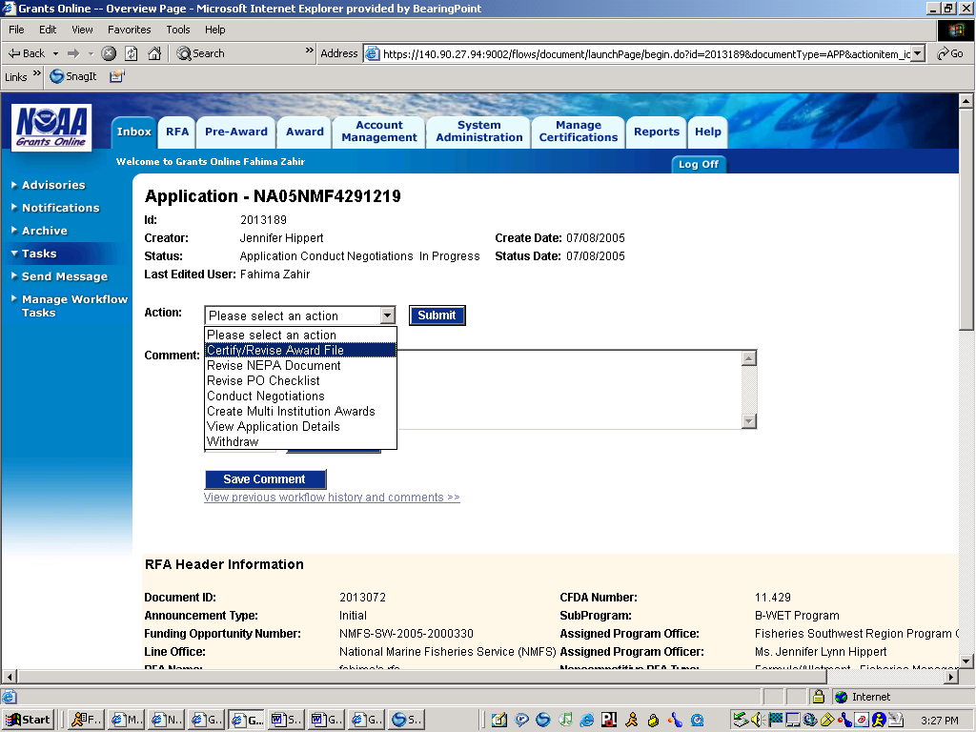
“Certify Revise Award File” Action

Step 11: The next screen is the task inbox screen. Remember to refresh your tasks. Select the “View" hyperlink from the “Certify/Revise Award File” task.

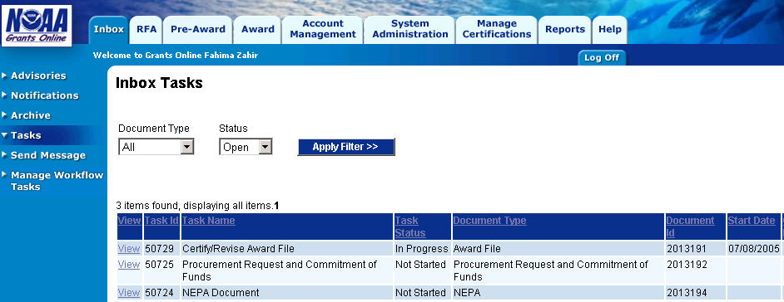
“Certify Revise Award File” Task

Step 12: From the action drop down menu, select the “Forward File to Grants Specialist” and click the “Submit” button. The award file is now sent to the Grants Specialist for review.

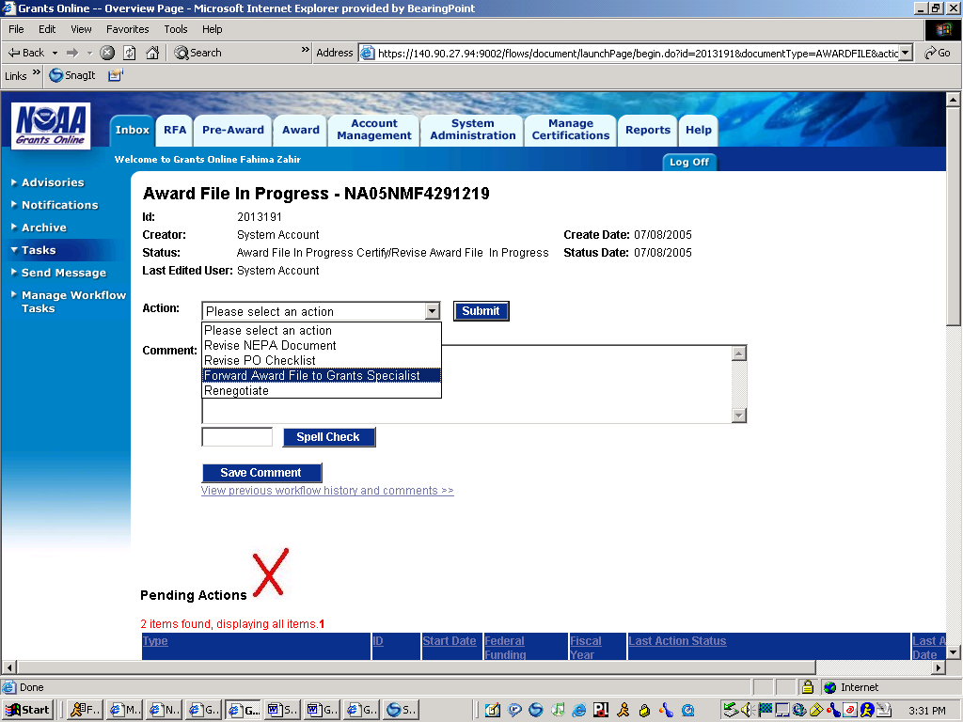
“Forward File to Grants Specialist” Action

